* 1. **Beans**: here we can create bunch of beans in the XML file. They have
     1. **Id**: we can name anything
     2. **Class**: name of class with full path.
  2. **ApplicationContext**: Spring container is known as application context. It is an interface with different implementation like **ClassPathXMLApplicationContext**, **AnnotationConfigApplicationContext**, **GenericWebApplicationContext** etc. In this case we need the ClassPathXMLApplicationContext implementation.

Here are the steps:

* Create an applicationcontext.xml file, by default it will look into the src folder.
* Create beans with id and class name.

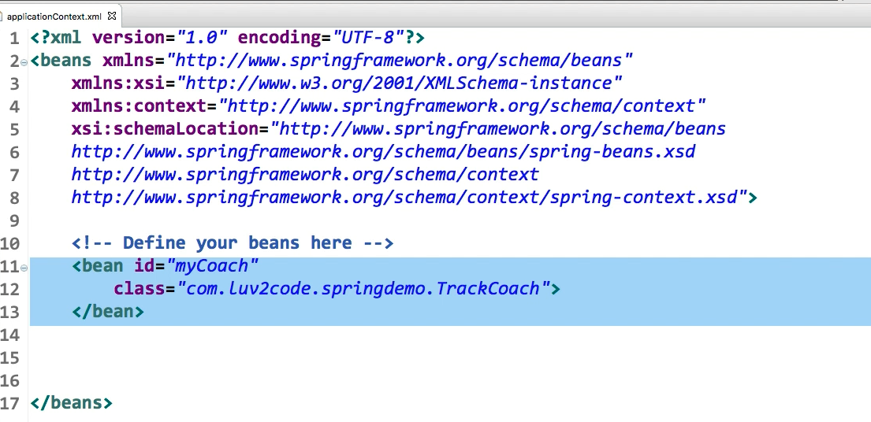

* In our app, load the configuration file and retrieve the bean. Here in the getBean () methods 2nd parameter, we have to define the class. Its best practice to use interface.
* After that we can use the bean and close the context.

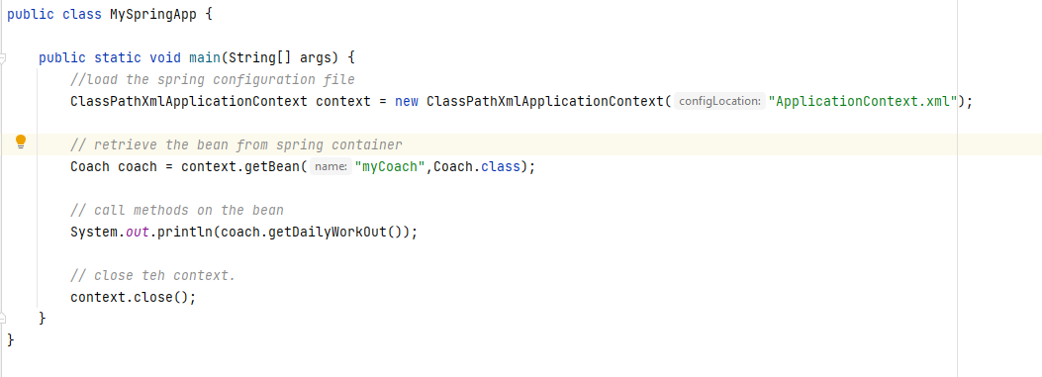

**Dependency Injection:** Spring have an object factory inside the spring container. There can be cases, that when we ask for an object, it can have additional dependencies on other objects. These are also known as helper object.

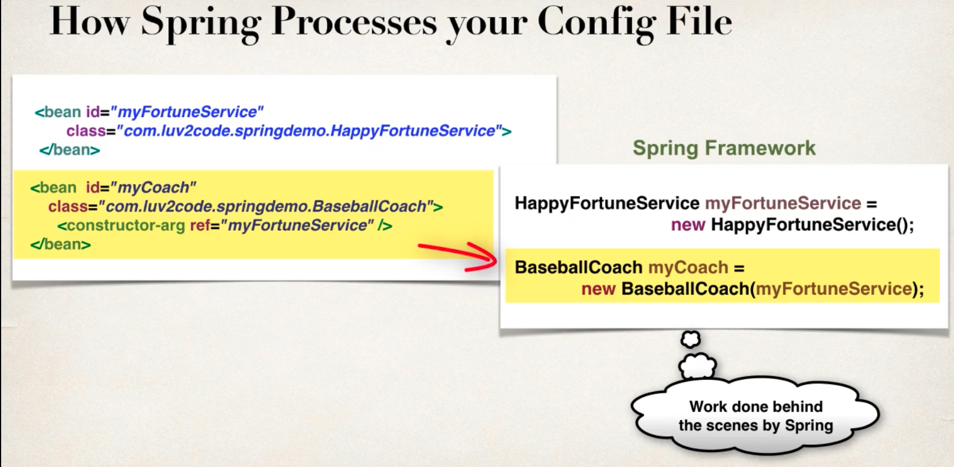

In these cases, instead of us manually building all the objects, spring factory handles all that.

There are different types of injections methods.

1. **Constructor Injection:** This is the recommended way for mandatory dependencies.Here we define the dependency in Interface and class. Then we create constructor in the class for injctions. And lastly, we configure the dependency injection in the spring config file.

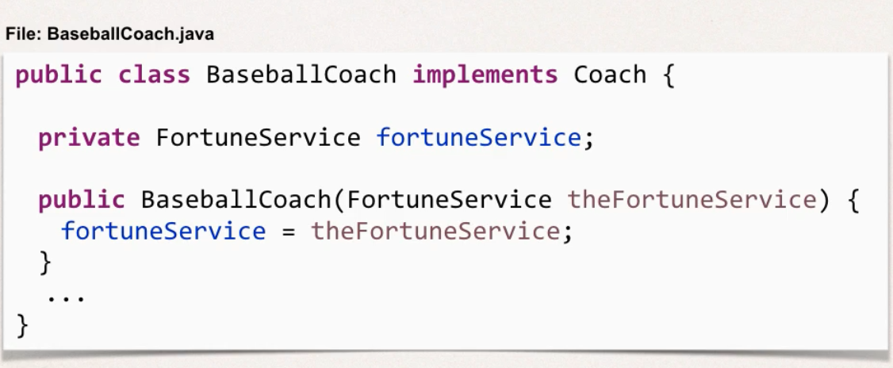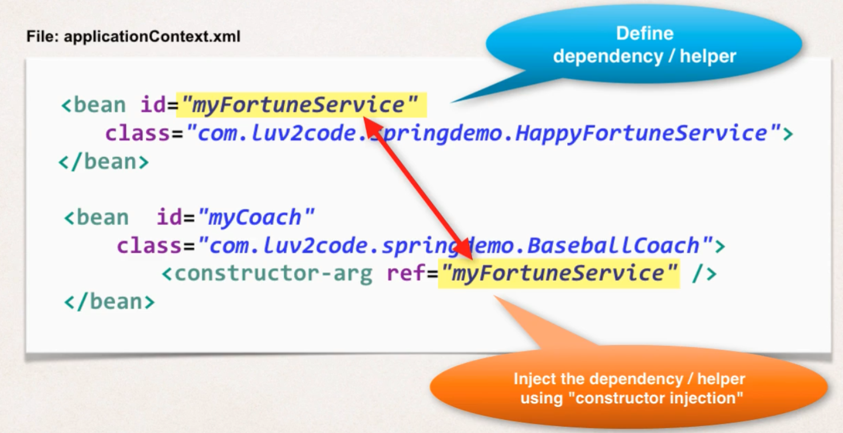

1. **Setter Injection:** This is recommended for optional dependencies and we should do a null check.
   1. Here, we first have to create the setter method in the class.
   2. Configure the dependency injection in the Spring config file

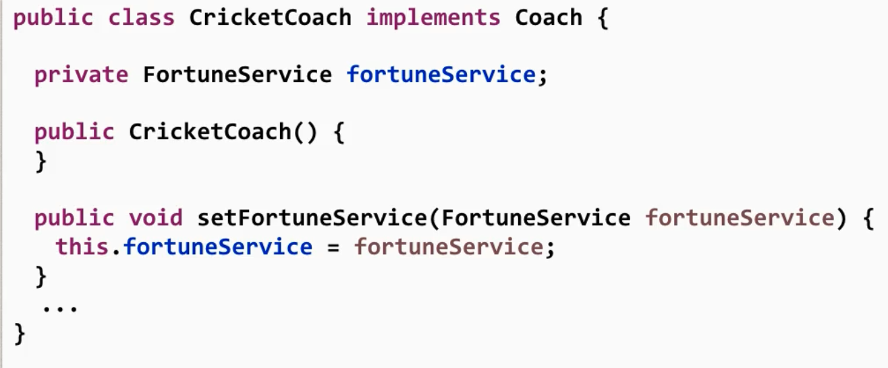 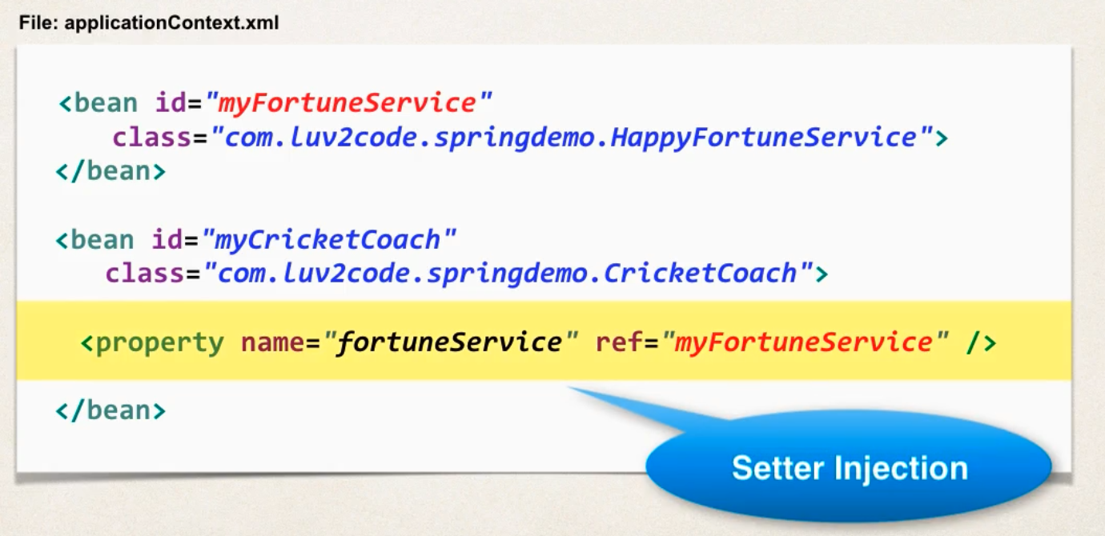

* 1. Property name is actually small letter, and it will look for capitalized first letter of that property name.

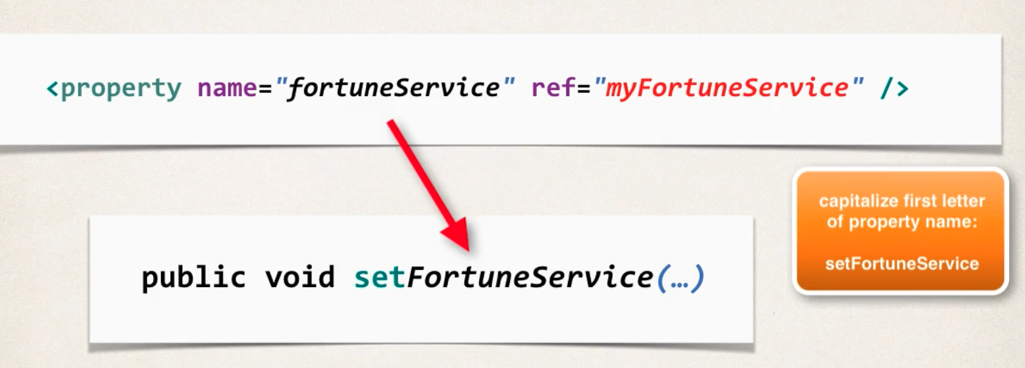

**Injecting Literal values:** We can inject literal values in the properties. This can be hardcoded values or read from a property file.

1. **Hard-Coded value**: we can create setters in the class for the fields, and then configure in the xml file.

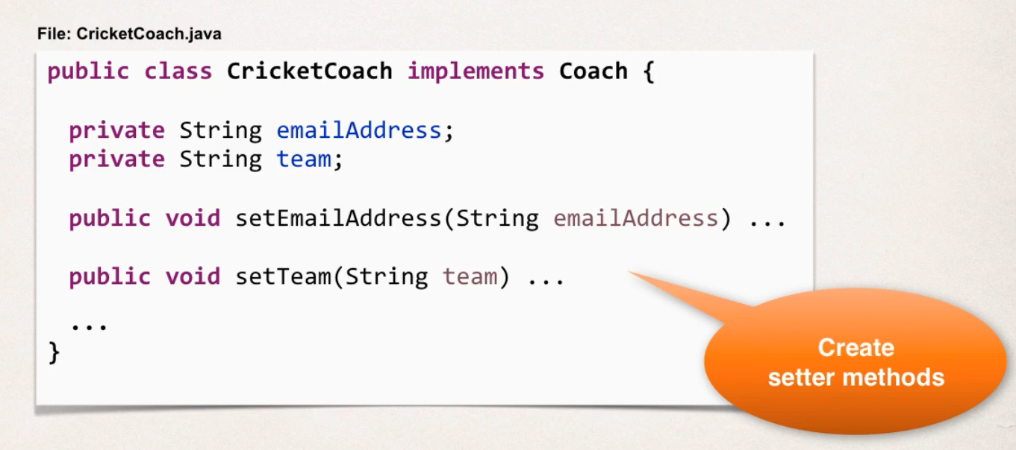 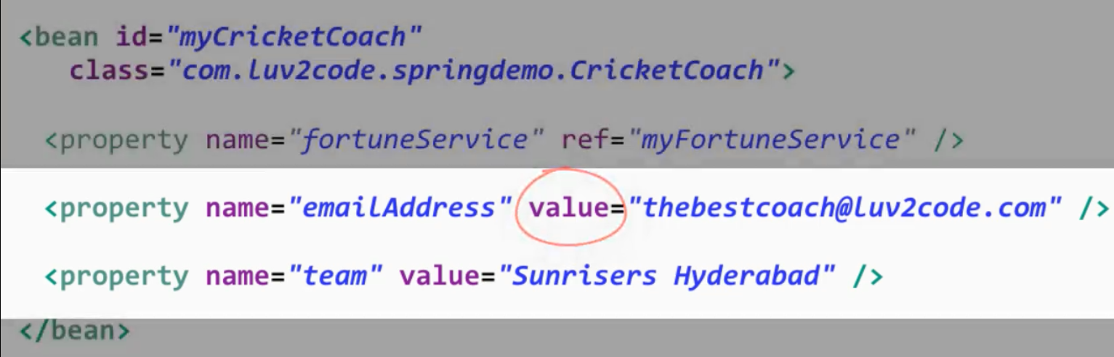

ii. **Read from property File:** Here we can specify the values in a property file.

* First, we define the properties in a .property file.
* Then, add a reference to the property file in the context property placeholder (this is used to load the props file in spring environment).
* Then we have to make the reference inside the bean.
* The syntax is like template string in Javascript, ${}

